LAB 3: Diode As A Clipper Circuit

**Date: Reg.#:**

## OBJECTIVES:

## To study diode as positive clipper, negative clipper and both waves clipper.

## To study diode as positive biased clipper, negative biased clipper and different biased level clipper.

## EQUIPMENT AND COMPONENTS:

* Basic Circuits Training Board
* 1N4007 Diode
* Jumper Wires
* Palm Scope / DMM
* Voltage Transformer/Function Generator
* Oscilloscope

---------------------------------------------------------------------------------------------------------------------

## Diode Clipping:

The Diode Clipper, also known as a Diode Limiter, is a wave shaping circuit that takes an input waveform and clips or cuts off its top half, bottom half or both halves together.

This clipping of the input signal produces an output waveform that resembles a flattened version of the input. For example, the half-wave rectifier is a clipper circuit, since all voltages below zero are eliminated.

The following are the types of diode clipping:

* Positive Clipper Circuit
* Negative Clipper Circuit
* Both Half Cycles Clipping

## Positive Clipper Circuit:

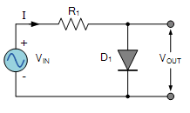

Fig: Positive Diode Clipper Circuit

In this diode clipping circuit, the diode is forward biased (anode more positive than cathode) during the positive half cycle of the sinusoidal input waveform. For the diode to become forward biased, it must have the input voltage magnitude greater than +0.7 volts (0.3 volts for a germanium diode).

During the negative half cycle, the diode is reverse biased (cathode more positive than anode) blocking current flow through itself and as a result has no effect on the negative half of the sinusoidal voltage which passes to the load unaltered. Thus the diode limits the positive half of the input waveform and is known as a positive clipper circuit.

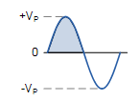 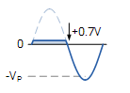

Fig: Positive Clipper Output

## Negative Clipper Circuit:

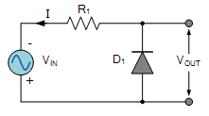

Fig: Negative Diode Clipper Circuit

Here the reverse is true. The diode is forward biased during the negative half cycle of the sinusoidal waveform and limits or clips it to –0.7 volts while allowing the positive half cycle to pass unaltered when reverse biased. As the diode limits the negative half cycle of the input voltage it is therefore called a negative clipper circuit.

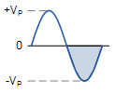 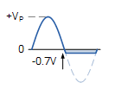

Fig: Negative Clipper Output

## Clipping of Both Half Cycles:

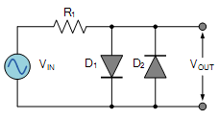

Fig: Both Half Cycles Clipper Circuit

If we connected two diodes in inverse parallel as shown, then both the positive and negative half cycles would be clipped as diode D1 clips the positive half cycle of the sinusoidal input waveform while diode D2 clips the negative half cycle. Then diode clipping circuits can be used to clip the positive half cycle, the negative half cycle or both.

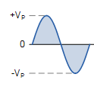 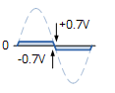

Fig: Both Half Cycles Clipper Output

## Biased Diode Clipping:

The following are the types of Biased Diode Clipping:

* Positive Bias Diode Clipping
* Negative Bias Diode Clipping
* Different Bias levels Clipping

## Positive Bias Diode Clipping:

To produce diode clipping circuits for voltage waveforms at different levels, a bias voltage, VBIAS is added in series with the diode to produce a combination clipper. The voltage across the series combination must be greater than VBIAS + 0.7V before the diode becomes sufficiently forward biased to conduct. Any anode voltage levels above the bias point are clipped off.

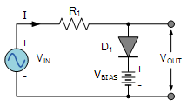

Fig: Positive Bias Diode Clipper Circuit

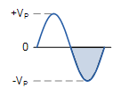 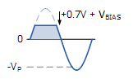

Fig: Positive Bias Diode Clipper Output

**Negative Bias** **Diode Clipping**:

Likewise, by reversing the diode and the battery bias voltage, when a diode conducts the negative half cycle of the output waveform is held to a level –VBIAS – 0.7V.

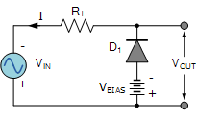

Fig: Negative Bias Diode Clipper Circuit

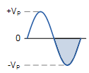 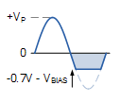

Fig: Negative Bias Diode Clipper Output

## Different Bias Levels Clipping:

A variable diode clipping or diode limiting level can be achieved by varying the bias voltage of the diodes. If both the positive and the negative half cycles are to be clipped, then two biased clipping diodes are used. But for both positive and negative diode clipping, the bias voltage need not be the same.

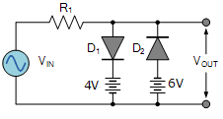

Fig: Different Bias Levels Clipper Circuit

When the voltage of the positive half cycle reaches +4.7 V, diode D1 conducts and limits the waveform at +4.7 V. Diode D2 does not conduct until the voltage reaches –6.7 V. Therefore, all positive voltages above +4.7 V and negative voltages below –6.7 V are automatically clipped.

If the diode clipping levels are set too low or the input waveform is too great then the elimination of both waveform peaks could end up with a square-wave shaped waveform.

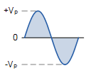 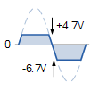

Fig: Different Bias Levels Clipper Output

## Observations:

**Vpp = _________**

**R = __________**

Attach the pictures of the corresponding output waveforms.

**Positive Clipper Output:**

**Negative Clipper Output:**

**Both Half Cycles Clipper Output:**

**Positive Bias Clipper Output:**

**Negative Bias Clipper Output:**

## Different Bias Levels Clipper Output:

# REVIEW QUESTIONS:

Q: What are the differences between series and shunt diode clippers?

Q: State the drawbacks of series and shunt diode clippers

Q: What are the applications of clipping circuits?